Record Keepers Report

John Kamau

18/07/2019

# Q7 Do you have a specific designation or role in the group?

|  |  |  |
| --- | --- | --- |
| Role | Mali | Uganda |
| Yes (please specify) | 143 | 123 |
| No | 8 | 15 |
| Respondents | 151 | 138 |

# Q7 Do you have a specific designation or role in the group? (Answered Yes)

|  |  |  |
| --- | --- | --- |
| Q_7_S | Mali | Uganda |
| Caissière | 50 | 0 |
| comparable | 1 | 0 |
| compte l’argent | 40 | 0 |
| détentrice de la caisse | 5 | 0 |
| garder l’argent | 2 | 0 |
| noter les cotisations | 1 | 0 |
| présidente | 1 | 0 |
| Record Keeper | 27 | 123 |
| tenir des registres | 9 | 0 |
| trésorière | 7 | 0 |
| Respondents | 143 | 123 |

# Q8 And in that role, what are your duties? Thank you. And what else? (Multiple Selection)

|  |  |  |
| --- | --- | --- |
| variable | Mali | Uganda |
| Keep written financial records | 87 | 134 |
| Remember how much people owe | 102 | 99 |
| Decide the penalties that members pay | 57 | 20 |
| Resolve conflicts around repayment | 52 | 51 |
| Resolve other conflicts between members | 55 | 27 |
| Train someone else to help keep the records | 37 | 52 |
| Compute the share out | 61 | 68 |
| It is an honorary or ceremonial post with no duties | 19 | 2 |
| Other (please specify) | 25 | 7 |
| Keep the savings balance safe | 12 | 42 |
| bring savings to the account | 3 | 22 |
| conduct all responsibilities with the account | 3 | 11 |
| Respondents | 153 | 155 |

# Q9 Are there other members who could fulfill your post, if you were not around? (Multiple Selection)

|  |  |  |
| --- | --- | --- |
| variable | Mali | Uganda |
| Yes, many | 86 | 22 |
| Yes, a few | 51 | 96 |
| I am training my replacement now | 5 | 13 |
| No, I am necessary. | 11 | 1 |
| I don’t know | 0 | 15 |
| Respondents | 151 | 138 |

# Q10 When was the group formed? I don’t know

# Q12 FUNCTION: How does the group operate?

|  |  |  |
| --- | --- | --- |
| Operate | Mali | Uganda |
| The group retains savings from meeting to meeting with prime purpose to lend out and give savings back (DISTRIBUTING ASCA) | 139 | 121 |
| The group retains savings indefinitely and lends to members for investment, household expenses, or to pay for members’ emergencies such as funerals (NON DISTRIBUTING ASCA) | 12 | 1 |
| The group collects savings at every meeting, and gives all the collected funds to one member in turn, and the group retains no money from meeting to meeting (ROSCA) | 0 | 2 |
| Other (specify) | 0 | 14 |
| Respondents | 151 | 138 |

|  |  |  |
| --- | --- | --- |
| Operate | Mali | Uganda |
| The group retains savings from meeting to meeting with prime purpose to lend out and give savings back (DISTRIBUTING ASCA) | 0.921 | 0.877 |
| The group retains savings indefinitely and lends to members for investment, household expenses, or to pay for members’ emergencies such as funerals (NON DISTRIBUTING ASCA) | 0.079 | 0.007 |
| The group collects savings at every meeting, and gives all the collected funds to one member in turn, and the group retains no money from meeting to meeting (ROSCA) | 0 | 0.014 |
| Other (specify) | 0 | 0.101 |
| Percentage | 1 | 1 |

# Q13 PURPOSE: What is the primary reason the group came together?

|  |  |  |
| --- | --- | --- |
| Reason | Mali | Uganda |
| Non-specific financial services | 4 | 79 |
| Farmers group | 0 | 12 |
| Social group | 86 | 20 |
| Women’s group | 28 | 4 |
| Business group | 0 | 6 |
| Other (specify) | 33 | 17 |
| Respondents | 151 | 138 |

|  |  |  |
| --- | --- | --- |
| Reason | Mali | Uganda |
| Non-specific financial services | 0.026 | 0.572 |
| Farmers group | 0 | 0.087 |
| Social group | 0.57 | 0.145 |
| Women’s group | 0.185 | 0.029 |
| Business group | 0 | 0.043 |
| Other (specify) | 0.219 | 0.123 |
| Percentage | 1 | 1 |

# 21 How often does your group meet?

|  |  |  |
| --- | --- | --- |
| meetings | Mali | Uganda |
| Weekly | 147 | 136 |
| Every 2 weeks | 4 | 1 |
| Monthly | 0 | 1 |
| Respondents | 151 | 138 |

|  |  |  |
| --- | --- | --- |
| meetings | Mali | Uganda |
| Weekly | 0.974 | 0.986 |
| Every 2 weeks | 0.026 | 0.007 |
| Monthly | 0 | 0.007 |
| Percentage | 1 | 1 |

# # Q22 How much does everyone contribute at each ROSCA meeting?

# 

# {r} # q7<-df[,grep("Country|Q_22",names(df)),with =F] # q7[,Value:=ifelse(Q_22<0,NA,Q_22)] # # q7%>%drop_na()%>%ggplot(aes(y=Value))+geom_boxplot(fill=colors[1])+facet_wrap(~Country)+labs(title ="How much does everyone contribute at each ROSCA meeting? SEEP-RK-22",x ="Uganda n=13",y="contributions")+scale_y_continuous(breaks =seq(0,10000,by =1000))+theme1+scale_fill_manual(values = 'colors') # #q7%>%drop_na()%>%count() # #B<-q7[,c(1,4)]%>%drop_na()%>%group_by(Country,meetings)%>%count()%>%dcast(meetings~Country) # #rbind(B,c("",Respondents=colSums(B[,2:3],na.rm=T)))%>%kable() #

# Q23 How does the group save?

|  |  |  |
| --- | --- | --- |
| Savings | Mali | Uganda |
| Each member saves exactly the same at every meeting during the cycle (but some members can save for 2 or 3 “mains”) | 135 | 7 |
| Each member saves the same at each meeting, but the amount fluctuates according to the economic situation (hunger months, we save less) (but some members can save for 2 or 3) | 3 | 12 |
| Each member can decide each meeting what to save, but minimum of one share, and there is a maximum number of shares | 9 | 92 |
| Each member can decide each meeting, no minimum but a maximum number of shares | 2 | 3 |
| Each member can decide each meeting what to save, no minimum, no maximum | 2 | 6 |
| Other (specify) | 0 | 2 |
| Respondents | 151 | 122 |

|  |  |  |
| --- | --- | --- |
| Savings | Mali | Uganda |
| Each member saves exactly the same at every meeting during the cycle (but some members can save for 2 or 3 “mains”) | 0.894 | 0.057 |
| Each member saves the same at each meeting, but the amount fluctuates according to the economic situation (hunger months, we save less) (but some members can save for 2 or 3) | 0.02 | 0.098 |
| Each member can decide each meeting what to save, but minimum of one share, and there is a maximum number of shares | 0.06 | 0.754 |
| Each member can decide each meeting, no minimum but a maximum number of shares | 0.013 | 0.025 |
| Each member can decide each meeting what to save, no minimum, no maximum | 0.013 | 0.049 |
| Other (specify) | 0 | 0.016 |
| Percentage | 1 | 1 |

# Q25 How many members started this cycle?

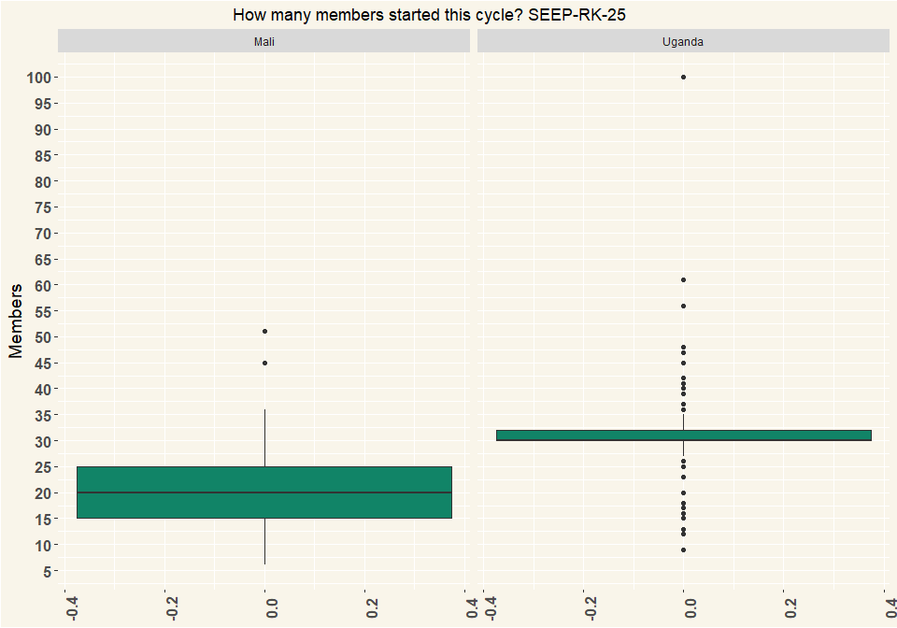

## # A tibble: 2 x 2  
## Country n  
## <chr> <int>  
## 1 Mali 151  
## 2 Uganda 122

# Q26 At the beginning of current cycle, how many of those members were women?

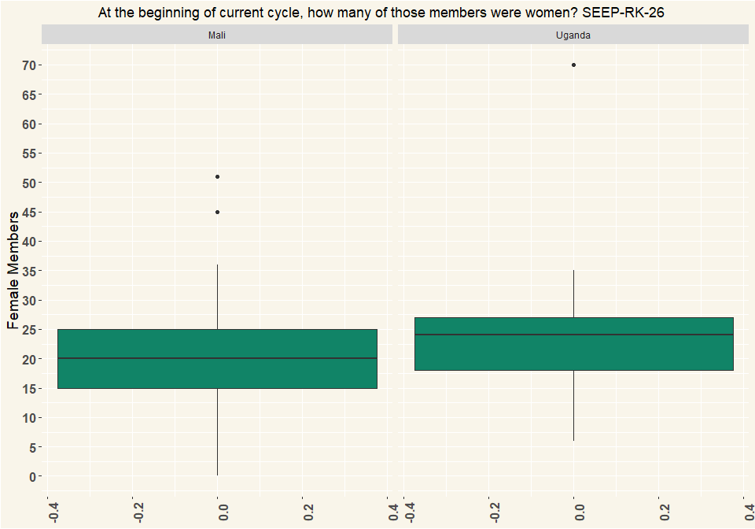

## # A tibble: 2 x 2  
## Country n  
## <chr> <int>  
## 1 Mali 151  
## 2 Uganda 122

# Q27 Are members allowed to withdraw their savings during the cycle?

|  |  |  |
| --- | --- | --- |
| Withdraw | Mali | Uganda |
| Yes | 22 | 6 |
| No | 117 | 115 |
| Respondents | 139 | 121 |

|  |  |  |
| --- | --- | --- |
| Withdraw | Mali | Uganda |
| Yes | 0.158 | 0.05 |
| No | 0.842 | 0.95 |
| Percentage | 1 | 1 |

# Q30 How many share outs do you remember and can you tell us about?

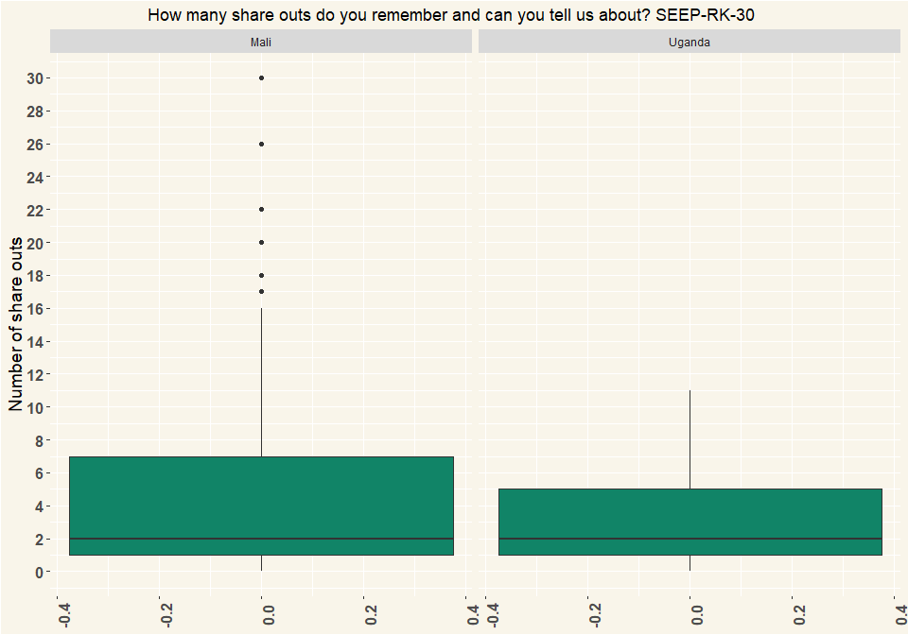

## # A tibble: 2 x 2  
## Country n  
## <chr> <int>  
## 1 Mali 139  
## 2 Uganda 121

# Q33 How many members participated in the share out?

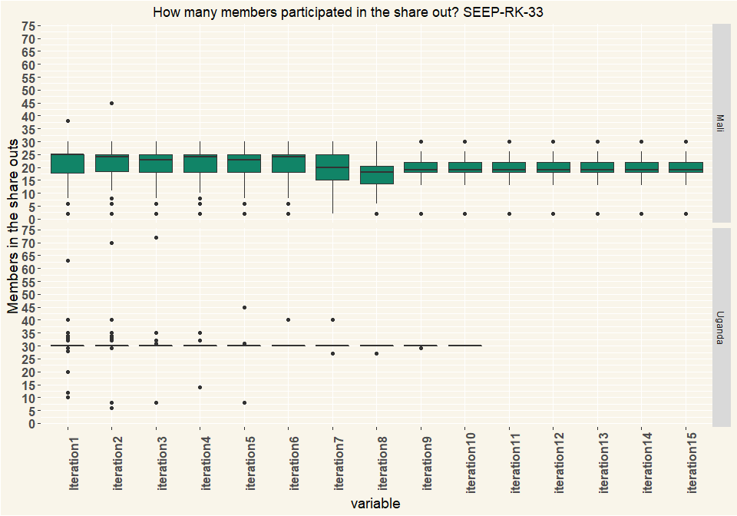

## # A tibble: 2 x 2  
## Country n  
## <chr> <int>  
## 1 Mali 151  
## 2 Uganda 138

# Q34 Were there any members who could not repay all their loans at share out?” (Multiple Selection)

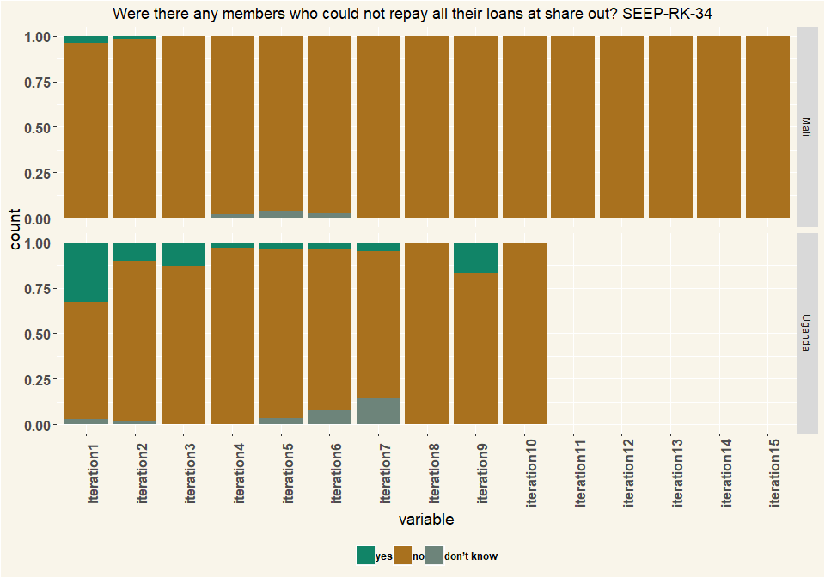

## # A tibble: 2 x 2  
## Country n  
## <chr> <int>  
## 1 Mali 151  
## 2 Uganda 138

# Q38 How many members does your group have today?

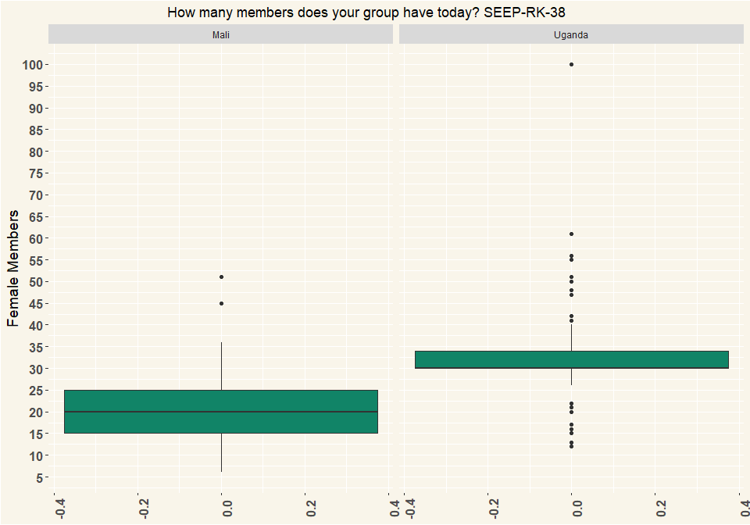

## # A tibble: 2 x 2  
## Country n  
## <chr> <int>  
## 1 Mali 151  
## 2 Uganda 138

# Q39 Thinking back to the most recent meeting of your group (Multiple Selection )

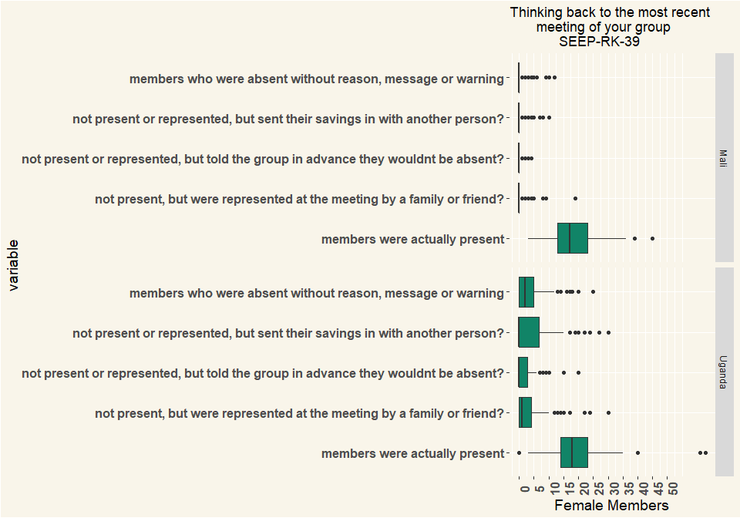

## # A tibble: 2 x 2  
## Country n  
## <chr> <int>  
## 1 Mali 151  
## 2 Uganda 138

# Q40 How are records kept in your group? What I mean by that, How do you know, from one meeting to the next, how much each person has saved, and each person has borrowed? (Multiple Selection)

|  |  |  |
| --- | --- | --- |
| variable | Mali | Uganda |
| Central ledger | 105 | 102 |
| Passbooks | 42 | 106 |
| Memory based system | 32 | 1 |
| Electronic recordkeeping application | 0 | 0 |
| Other (specify) | 0 | 0 |
| Don’t know, can’t say | 13 | 7 |
| Respondents | 153 | 155 |

# Q41 When the group conducts a transaction (for example, a member deposits savings or makes a loan repayment) how is the money handled? (multiple Selection)

|  |  |  |
| --- | --- | --- |
| variable | Mali | Uganda |
| Member brings it to the money counter(s), who counts the money and confirm the amount to the Recordkeeper | 108 | 129 |
| Member brings it to the money counter(s), who don’t count the money and put it in a box | 62 | 4 |
| Member brings it to the Recordkeeper, who counts the money and confirms the amount | 13 | 6 |
| Member brings it to the Recordkeeper, the money is not counted, the amount is not confirmed | 1 | 0 |
| Group does not use cash (describe) | 0 | 1 |
| Other | 2 | 2 |
| Respondents | 153 | 155 |

# Q42 How is money kept between meetings? (Multiple Selection)

|  |  |  |
| --- | --- | --- |
| variable | Mali | Uganda |
| In a cashbox or other secure container. One person keeps the box, two or more people have keys | 20 | 119 |
| In a cashbox or other secure container. One person keeps the box, one person has keys | 115 | 3 |
| In a cashbox or other secure container. Same person keeps box and key. | 2 | 2 |
| In a box or container, unlocked. | 0 | 1 |
| Money is split up among members | 0 | 25 |
| Bank account | 0 | 7 |
| We don’t keep cash (describe how that works) | 0 | 0 |
| We never have cash because we lend out all the money | 0 | 1 |
| Other | 14 | 2 |
| Respondents | 153 | 155 |

|  |  |  |
| --- | --- | --- |
| variable | Mali | Uganda |
| In a cashbox or other secure container. One person keeps the box, two or more people have keys | 0.132 | 0.744 |
| In a cashbox or other secure container. One person keeps the box, one person has keys | 0.762 | 0.019 |
| In a cashbox or other secure container. Same person keeps box and key. | 0.013 | 0.012 |
| In a box or container, unlocked. | 0 | 0.006 |
| Money is split up among members | 0 | 0.156 |
| Bank account | 0 | 0.044 |
| We don’t keep cash (describe how that works) | 0 | 0 |
| We never have cash because we lend out all the money | 0 | 0.006 |
| Other | 0.093 | 0.012 |
| Percentage | 1 | 1 |

# Q44 Has your group ever had money stolen?

|  |  |  |
| --- | --- | --- |
| Money | Mali | Uganda |
| Yes | 2 | 10 |
| No | 137 | 109 |
| I don’t know | 0 | 2 |
| Respondents | 139 | 121 |

|  |  |  |
| --- | --- | --- |
| Money | Mali | Uganda |
| Yes | 0.014 | 0.083 |
| No | 0.986 | 0.901 |
| I don’t know | 0 | 0.017 |
| Percentage | 1 | 1 |

# Q47 Does your group still receive visits from {NGO name}?

|  |  |  |
| --- | --- | --- |
| Visit | Mali | Uganda |
| Yes | 0 | 21 |
| No | 151 | 117 |
| Respondents | 151 | 138 |

|  |  |  |
| --- | --- | --- |
| Visit | Mali | Uganda |
| Yes | 0 | 0.152 |
| No | 1 | 0.848 |
| Percentage | 1 | 1 |

# Q48 How often does the group receive visits from {NGO name}?

|  |  |  |
| --- | --- | --- |
| Visit | Mali | Uganda |
| Every week | 0 | 2 |
| Every two weeks | 1 | 1 |
| Every year | 0 | 1 |
| Sporadically, once every few years | 0 | 7 |
| It varies | 0 | 10 |
| Other (specify) | 0 | 1 |
| Respondents | 1 | 22 |

|  |  |  |
| --- | --- | --- |
| Visit | Mali | Uganda |
| Every week | 0 | 0.091 |
| Every two weeks | 1 | 0.045 |
| Every year | 0 | 0.045 |
| Sporadically, once every few years | 0 | 0.318 |
| It varies | 0 | 0.455 |
| Other (specify) | 0 | 0.045 |
| Percentage | 1 | 1 |

# Q50 Did someone help the group at last share-out?

|  |  |  |
| --- | --- | --- |
| Help | Mali | Uganda |
| Yes | 15 | 42 |
| No | 124 | 79 |
| Respondents | 139 | 121 |

|  |  |  |
| --- | --- | --- |
| Help | Mali | Uganda |
| Yes | 0.108 | 0.347 |
| No | 0.892 | 0.653 |
| Percentage | 1 | 1 |

# Q51 Who provided help?

|  |  |  |
| --- | --- | --- |
| Help | Mali | Uganda |
| former trainer | 0 | 7 |
| l’enseignant | 2 | 0 |
| Lamine Diarra secrétairecdu groupe | 1 | 0 |
| NGO or CBO | 2 | 5 |
| the trainer | 0 | 1 |
| Volunteer or Village Agent or Replicator | 11 | 29 |
| Respondents | 16 | 42 |

|  |  |  |
| --- | --- | --- |
| Help | Mali | Uganda |
| former trainer | 0 | 0.167 |
| l’enseignant | 0.125 | 0 |
| Lamine Diarra secrétairecdu groupe | 0.062 | 0 |
| NGO or CBO | 0.125 | 0.119 |
| the trainer | 0 | 0.024 |
| Volunteer or Village Agent or Replicator | 0.688 | 0.69 |
| Percentage | 1 | 1 |

# Q52 Do you or anyone in your group know how to calculate the share out so that each person gets the right amount?

|  |  |  |
| --- | --- | --- |
| calculate | Mali | Uganda |
| Yes | 102 | 88 |
| No | 37 | 22 |
| I don’t know myself and I don’t know whether others can do it | 0 | 11 |
| Respondents | 139 | 121 |

|  |  |  |
| --- | --- | --- |
| calculate | Mali | Uganda |
| Yes | 0.734 | 0.727 |
| No | 0.266 | 0.182 |
| I don’t know myself and I don’t know whether others can do it | 0 | 0.091 |
| NA | 1 | 1 |

# Q53 How many members know how to calculate the share-out?

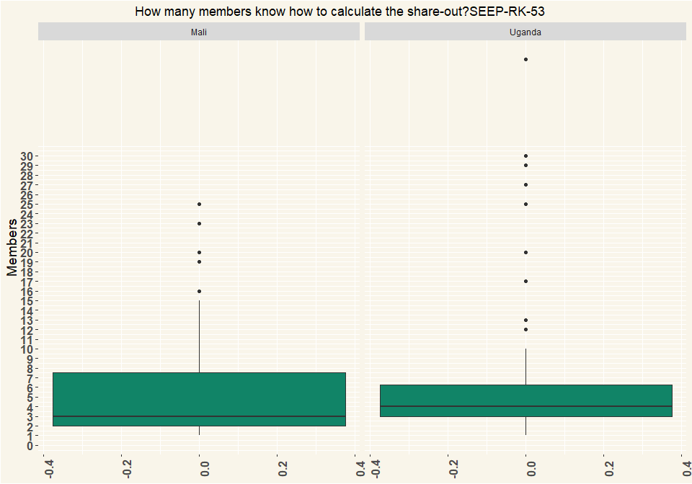

## # A tibble: 2 x 2  
## Country n  
## <chr> <int>  
## 1 Mali 103  
## 2 Uganda 88

# Q54 Why don’t more members know how to calculate the share-out? (Multiple Selection)

|  |  |  |
| --- | --- | --- |
| variable | Mali | Uganda |
| They don’t need to, we have enough, we are happy the way it is | 38 | 9 |
| They are not educated or literate | 89 | 61 |
| No one has shown us | 19 | 17 |
| Other: | 4 | 7 |
| Respondents | 150 | 94 |

|  |  |  |
| --- | --- | --- |
| variable | Mali | Uganda |
| They don’t need to, we have enough, we are happy the way it is | 0.253 | 0.096 |
| They are not educated or literate | 0.593 | 0.649 |
| No one has shown us | 0.127 | 0.181 |
| Other: | 0.027 | 0.074 |
| Percentage | 1 | 1 |

# Q55 The most recent time you shared out, did all the members receive the amount they expected?

|  |  |  |
| --- | --- | --- |
| calculate | Mali | Uganda |
| Yes, all were content | 131 | 101 |
| Yes, more or less, most were content | 3 | 14 |
| No, a few challenged the amount they got | 3 | 4 |
| No, some were very dissatisfied | 2 | 1 |
| Other (specify) | 0 | 1 |
| Respondents | 139 | 121 |

|  |  |  |
| --- | --- | --- |
| calculate | Mali | Uganda |
| Yes, all were content | 0.942 | 0.835 |
| Yes, more or less, most were content | 0.022 | 0.116 |
| No, a few challenged the amount they got | 0.022 | 0.033 |
| No, some were very dissatisfied | 0.014 | 0.008 |
| Other (specify) | 0 | 0.008 |
| Percentage | 1 | 1 |

# Q56 What caused the amount to be lower than expected?”(Multiple Selection)

|  |  |  |
| --- | --- | --- |
| variable | Mali | Uganda |
| We lost money from late loans | 0 | 4 |
| We lost money from external theft | 0 | 0 |
| We had a failed group investment | 0 | 0 |
| We lost money but we don’t know how | 2 | 0 |
| Some members were suspicious about calculations | 0 | 1 |
| Some members are never happy | 0 | 1 |
| Don’t know | 2 | 1 |
| other (specify) | 2 | 0 |
| Respondents | 6 | 7 |

|  |  |  |
| --- | --- | --- |
| variable | Mali | Uganda |
| We lost money from late loans | 0 | 0.571 |
| We lost money from external theft | 0 | 0 |
| We had a failed group investment | 0 | 0 |
| We lost money but we don’t know how | 0.333 | 0 |
| Some members were suspicious about calculations | 0 | 0.143 |
| Some members are never happy | 0 | 0.143 |
| Don’t know | 0.333 | 0.143 |
| other (specify) | 0.333 | 0 |
| NA | 1 | 1 |

# Q57 How long is a savings cycle usually in months?

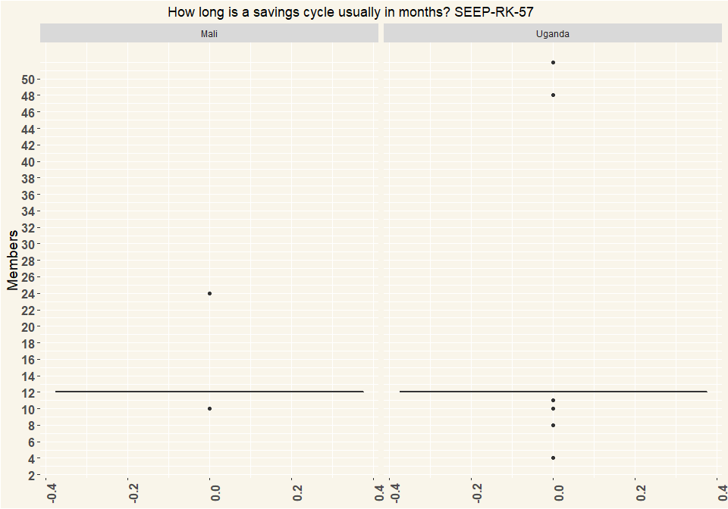

## # A tibble: 2 x 2  
## Country n  
## <chr> <int>  
## 1 Mali 139  
## 2 Uganda 121

# Q58 How is the share-out calculated?

|  |  |  |
| --- | --- | --- |
| calculate | Mali | Uganda |
| Everybody gets back what they saved and paid (interest paid on loans goes back to the person paying) | 45 | 20 |
| Everybody gets their saving back and the remainder split equally amongst the members | 40 | 5 |
| Everybody gets their savings back and the interest is distributed proportionately | 41 | 90 |
| All the money is split up evenly among all the members regardless of how they have saved. | 0 | 2 |
| Everybody gets an exact share according to participation (1, 2 or 3 ‘mains’) | 13 | 2 |
| other (specify) | 0 | 2 |
| Respondents | 139 | 121 |

|  |  |  |
| --- | --- | --- |
| calculate | Mali | Uganda |
| Everybody gets back what they saved and paid (interest paid on loans goes back to the person paying) | 0.324 | 0.165 |
| Everybody gets their saving back and the remainder split equally amongst the members | 0.288 | 0.041 |
| Everybody gets their savings back and the interest is distributed proportionately | 0.295 | 0.744 |
| All the money is split up evenly among all the members regardless of how they have saved. | 0 | 0.017 |
| Everybody gets an exact share according to participation (1, 2 or 3 ‘mains’) | 0.094 | 0.017 |
| other (specify) | 0 | 0.017 |
| Percentage | 1 | 1 |

# Q59 Does your group charge fines for members who break the rules?

|  |  |  |
| --- | --- | --- |
| Fines | Mali | Uganda |
| Yes | 142 | 129 |
| No | 9 | 6 |
| In principle yes but in reality no | 0 | 3 |
| Respondents | 151 | 138 |

|  |  |  |
| --- | --- | --- |
| Fines | Mali | Uganda |
| Yes | 0.94 | 0.935 |
| No | 0.06 | 0.043 |
| In principle yes but in reality no | 0 | 0.022 |
| Percentage | 1 | 1 |

# Q60 What are some of the things that members are fined for? (Multiple Selection)

|  |  |  |
| --- | --- | --- |
| variable | Mali | Uganda |
| Talking during meeting | 123 | 72 |
| Late to meeting | 148 | 120 |
| Late repayment | 122 | 87 |
| Not saving | 126 | 49 |
| Arguments, saying bad things | 80 | 49 |
| Phone ringing during meeting | 13 | 13 |
| Other: | 2 | 16 |
| Respondents | 153 | 155 |

# Q61 Is the group registered with any government authority? E.g. with the municipality, ministry of cooperatives, chamber of commerce, etc.

|  |  |  |
| --- | --- | --- |
| Registration | Mali | Uganda |
| Yes | 37 | 77 |
| No | 104 | 51 |
| I don’t know | 10 | 10 |
| Respondents | 151 | 138 |

|  |  |  |
| --- | --- | --- |
| Registration | Mali | Uganda |
| Yes | 0.245 | 0.558 |
| No | 0.689 | 0.37 |
| I don’t know | 0.066 | 0.072 |
| Percentage | 1 | 1 |

# Q62 Does the group have a relationship with a financial service provider?

|  |  |  |
| --- | --- | --- |
| Financial | Mali | Uganda |
| Yes, as a group | 6 | 26 |
| Yes, but individual members | 6 | 28 |
| No, nobody has any relationship | 136 | 64 |
| I don’t know | 3 | 20 |
| Respondents | 151 | 138 |

|  |  |  |
| --- | --- | --- |
| Financial | Mali | Uganda |
| Yes, as a group | 0.04 | 0.188 |
| Yes, but individual members | 0.04 | 0.203 |
| No, nobody has any relationship | 0.901 | 0.464 |
| I don’t know | 0.02 | 0.145 |
| Percentage | 1 | 1 |

# Q63 What type of relationship(s) does the group have with a financial service provider? (Multiple Selection)

|  |  |  |
| --- | --- | --- |
| variable | Mali | Uganda |
| Individual group members have accounts (unrelated to the group) | 6 | 41 |
| Individual group members have loans (unrelated to the group, group not guaranteeing loan) | 5 | 25 |
| Individual group members have accounts as a result of the group | 0 | 1 |
| Group has an account (e.g. for excess funds) | 6 | 20 |
| Group has a loan from financial service provider | 1 | 3 |
| I don’t know | 0 | 0 |
| I don’t want to answer | 0 | 0 |
| other (specify) | 0 | 0 |
| Respondents | 18 | 90 |

|  |  |  |
| --- | --- | --- |
| variable | Mali | Uganda |
| Individual group members have accounts (unrelated to the group) | 0.333 | 0.456 |
| Individual group members have loans (unrelated to the group, group not guaranteeing loan) | 0.278 | 0.278 |
| Individual group members have accounts as a result of the group | 0 | 0.011 |
| Group has an account (e.g. for excess funds) | 0.333 | 0.222 |
| Group has a loan from financial service provider | 0.056 | 0.033 |
| I don’t know | 0 | 0 |
| I don’t want to answer | 0 | 0 |
| other (specify) | 0 | 0 |
| Percentage | 1 | 1 |

# Q64 In what type of institution does the group have an account(?) (Multiple Selection)

|  |  |  |
| --- | --- | --- |
| variable | Mali | Uganda |
| Commercial Bank | 0 | 5 |
| MDIs | 0 | 0 |
| MFIs | 4 | 2 |
| SACCOs | 0 | 4 |
| MNO (mobile money) | 0 | 0 |
| Other (specify) | 1 | 0 |
| I don’t want to answer | 0 | 0 |
| Respondents | 5 | 11 |

|  |  |  |
| --- | --- | --- |
| variable | Mali | Uganda |
| Commercial Bank | 0 | 0.455 |
| MDIs | 0 | 0 |
| MFIs | 0.8 | 0.182 |
| SACCOs | 0 | 0.364 |
| MNO (mobile money) | 0 | 0 |
| Other (specify) | 0.2 | 0 |
| I don’t want to answer | 0 | 0 |
| Percentage | 1 | 1 |

# Q67 Does the group use mobile money for group activities?

|  |  |  |
| --- | --- | --- |
| Mobile | Mali | Uganda |
| Yes | 0 | 1 |
| No | 147 | 134 |
| I don’t know | 4 | 3 |
| Respondents | 151 | 138 |

|  |  |  |
| --- | --- | --- |
| Mobile | Mali | Uganda |
| Yes | 0 | 0.007 |
| No | 0.974 | 0.971 |
| I don’t know | 0.026 | 0.022 |
| Percentage | 1 | 1 |

# Q69 Does the group use any form of technology for recordkeeping? E.g. calculator on phone? an app on a phone to do bookkeeping?

|  |  |  |
| --- | --- | --- |
| Tech | Mali | Uganda |
| Yes | 32 | 126 |
| No | 119 | 12 |
| Respondents | 151 | 138 |

|  |  |  |
| --- | --- | --- |
| Tech | Mali | Uganda |
| Yes | 0.212 | 0.913 |
| No | 0.788 | 0.087 |
| Percentage | 1 | 1 |

# Q70 What forms of technology does the group use? (Multiple Selection)

|  |  |  |
| --- | --- | --- |
| variable | Mali | Uganda |
| Stand-alone calculator | 30 | 63 |
| Calculator on simple phone | 25 | 111 |
| Calculator on smart phone | 19 | 9 |
| Sending messages on simple phone | 2 | 10 |
| Sending messages on smart phone | 0 | 4 |
| Recording numbers or balances on simple phone | 0 | 0 |
| Recording numbers or balances on smart phone | 0 | 1 |
| Camera on simply phone | 0 | 11 |
| Camera on smart phone | 0 | 4 |
| Other (specify) | 0 | 0 |
| Respondents | 151 | 138 |

|  |  |  |
| --- | --- | --- |
| variable | Mali | Uganda |
| Stand-alone calculator | 0.395 | 0.296 |
| Calculator on simple phone | 0.329 | 0.521 |
| Calculator on smart phone | 0.25 | 0.042 |
| Sending messages on simple phone | 0.026 | 0.047 |
| Sending messages on smart phone | 0 | 0.019 |
| Recording numbers or balances on simple phone | 0 | 0 |
| Recording numbers or balances on smart phone | 0 | 0.005 |
| Camera on simply phone | 0 | 0.052 |
| Camera on smart phone | 0 | 0.019 |
| Other (specify) | 0 | 0 |
| Percentage | 1 | 1 |

# Q74 What is the gender of the respondent?

|  |  |  |
| --- | --- | --- |
| Gender | Mali | Uganda |
| Female | 149 | 84 |
| Male | 2 | 54 |
| Respondents | 151 | 138 |

|  |  |  |
| --- | --- | --- |
| Gender | Mali | Uganda |
| Female | 0.987 | 0.609 |
| Male | 0.013 | 0.391 |
| Percentage | 1 | 1 |

# Q75 Could you estimate the age of the respondent? I don’t know

